H.T No
Regulations:
A14

Sreenidhi Institute of Science and Technology
(An Autonomous Institution)
Code No: 4FC17 Date: 20-Nov-2020 (FN)

B.Tech III-Year II-Semester External Examination, Nov/Dec - 2020 (Supplementary)
THEORY OF COMPUTATION (ECM)

Time: 2 Hours Max.Marks:70

Note: a) No additional answer sheets will be provided.
b) All sub-parts of a question must be answered at one place only, otherwise it will not be valued.
c) Missing data can be assumed suitably.

ANSWER ANY 5 OUT OF 8 QUESTIONS. EACH QUESTION CARRIES 14 MARKS.

1. | a) | Design DFA accepting the language whose binary interpretation is divisible by 5 over the alphabet {0, 1}. | [7M]
 | b) | Design a NFA which contains 101 as a substring over an alphabet {0, 1}. | [7M]
2. | a) | Construct a NFA without ∈ for the following NFA with ∈.  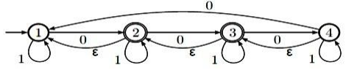 | [7M]
 | b) | Differentiate between moore and melay machines. | [7M]
3. | a) | Construct regular expression for the given DFA.  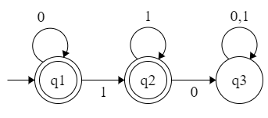 | [7M]
 | b) | Obtain a Right Linear Grammar for the language L = {a^{n} b^{m} | n>=2 , m>=3} | [7M]
4. |  | For the following grammar :  S → ABC | BbB , A→ aA | BaC|aaa , B→ bBb| a|D, C→CA|AC , D→ ε  - Eliminate ε-productions.  - Eliminate any unit productions in the resulting grammar.  - Eliminate any useless symbols in the resulting grammar.  - Put the resulting grammar in Chomsky Normal Form. | [14M]
5. | a) | Explain computable functions. | [7M]
 | b) | Design a Turing Machine to addition of 2 integers. | [7M]
6. | a) | construct LR(0) items for the grammar  S→AA | a, A→ SA | b | [7M]
 | b) | Determine whether the following PCP problem has a solution or not.  X={10, 011, 101} Y={101, 11, 011} | [7M]
7. | a) | Define string, alphabet and language. | [7M]
 | b) | Construct a Mealy machine which is equivalent to the Moore machine.  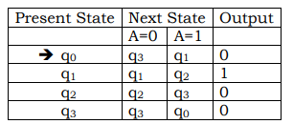 | [7M]
8. | a) | Design a PDA which accepts L = {0^{n}1^{n} |n>=1}. | [7M]
 | b) | Explain Church’s hypothesis. | [7M]

-- 00 -- 00 –

